***Decision tree for Azure Services***

URL: <https://docs.microsoft.com/en-us/azure/architecture/guide/technology-choices/compute-decision-tree?view=azs-2108>

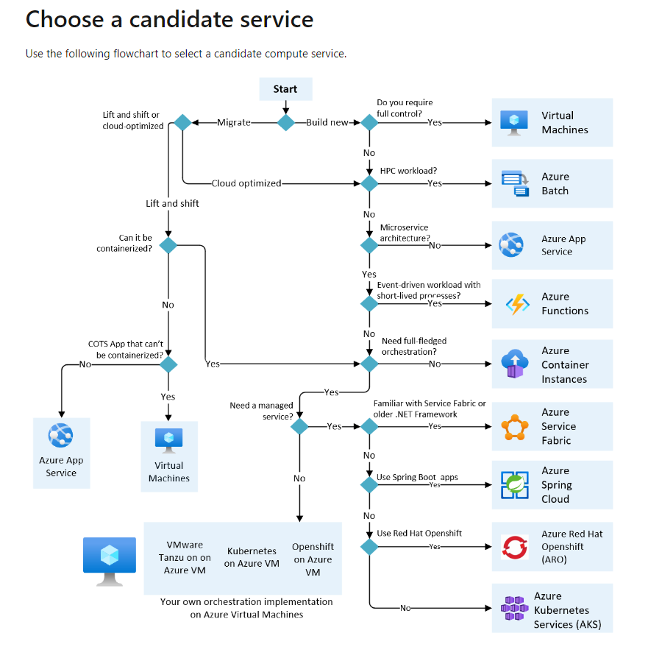

High Availability and disaster recovery scenarios for Azure IaaS apps

URL: <https://docs.microsoft.com/en-us/azure/architecture/example-scenario/infrastructure/iaas-high-availability-disaster-recovery?view=azs-2108>

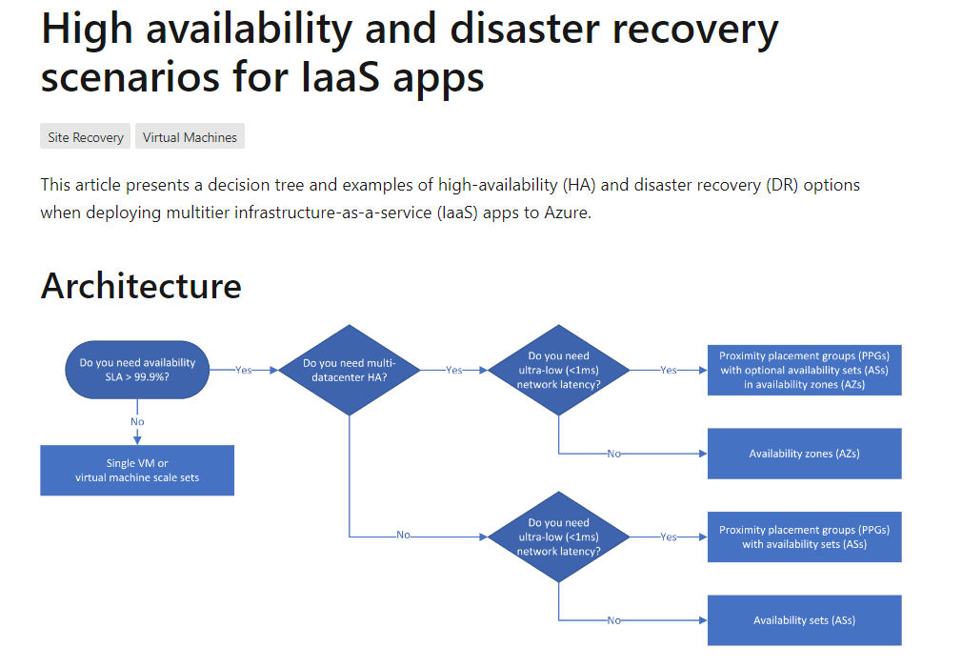

https://docs.microsoft.com/en-us/azure/architecture/guide/technology-choices/multiparty-computing-service?view=azs-2108

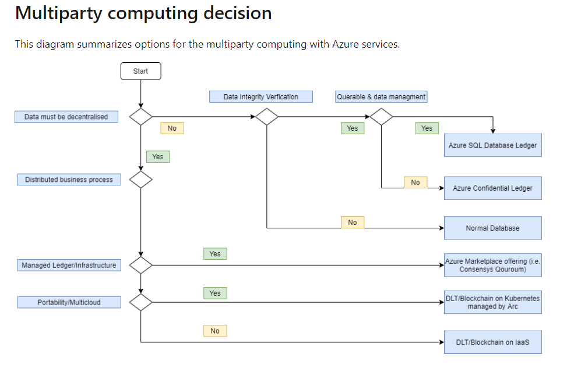

URL:

<https://docs.microsoft.com/en-us/azure-stack/operator/compare-azure-azure-stack?view=azs-2108&toc=https%3A%2F%2Fdocs.microsoft.com%2Fen-us%2Fazure%2Farchitecture%2Ftoc.json%3Fview%3Dazs-2108&bc=https%3A%2F%2Fdocs.microsoft.com%2Fen-us%2Fazure%2Farchitecture%2Fbread%2Ftoc.json%3Fview%3Dazs-2108>

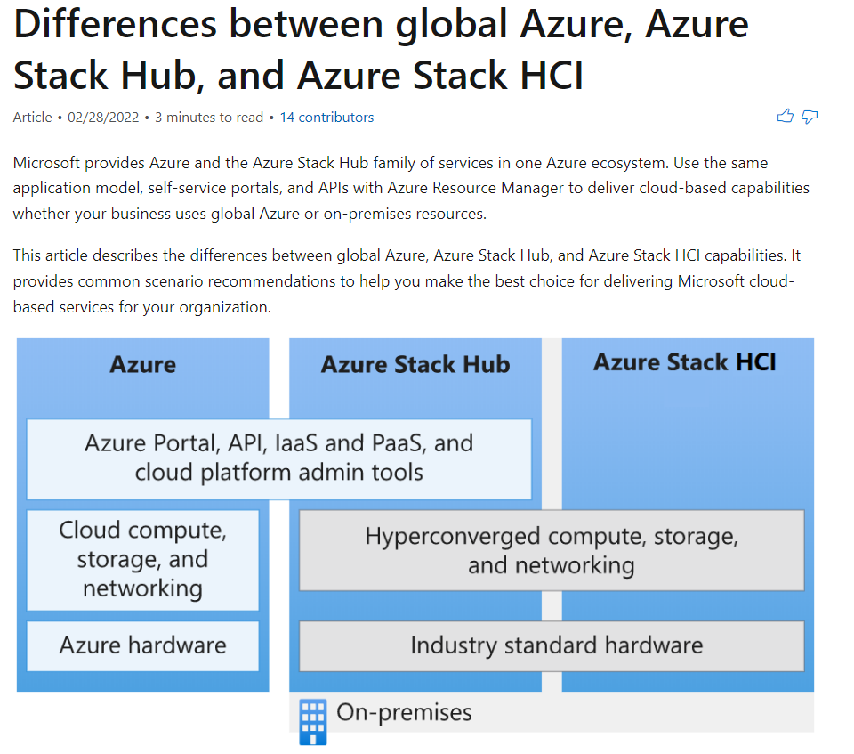

When to Use Azure Stack HCI:

url: <https://docs.microsoft.com/en-us/azure-stack/hci/concepts/compare-windows-server?view=azs-2108&toc=https%3A%2F%2Fdocs.microsoft.com%2Fen-us%2Fazure%2Farchitecture%2Ftoc.json%3Fview%3Dazs-2108&bc=https%3A%2F%2Fdocs.microsoft.com%2Fen-us%2Fazure%2Farchitecture%2Fbread%2Ftoc.json%3Fview%3Dazs-2108>

drive types for HCI:

<https://docs.microsoft.com/en-us/azure-stack/hci/concepts/choose-drives?view=azs-2108&toc=https%3A%2F%2Fdocs.microsoft.com%2Fen-us%2Fazure%2Farchitecture%2Ftoc.json%3Fview%3Dazs-2108&bc=https%3A%2F%2Fdocs.microsoft.com%2Fen-us%2Fazure%2Farchitecture%2Fbread%2Ftoc.json%3Fview%3Dazs-2108>

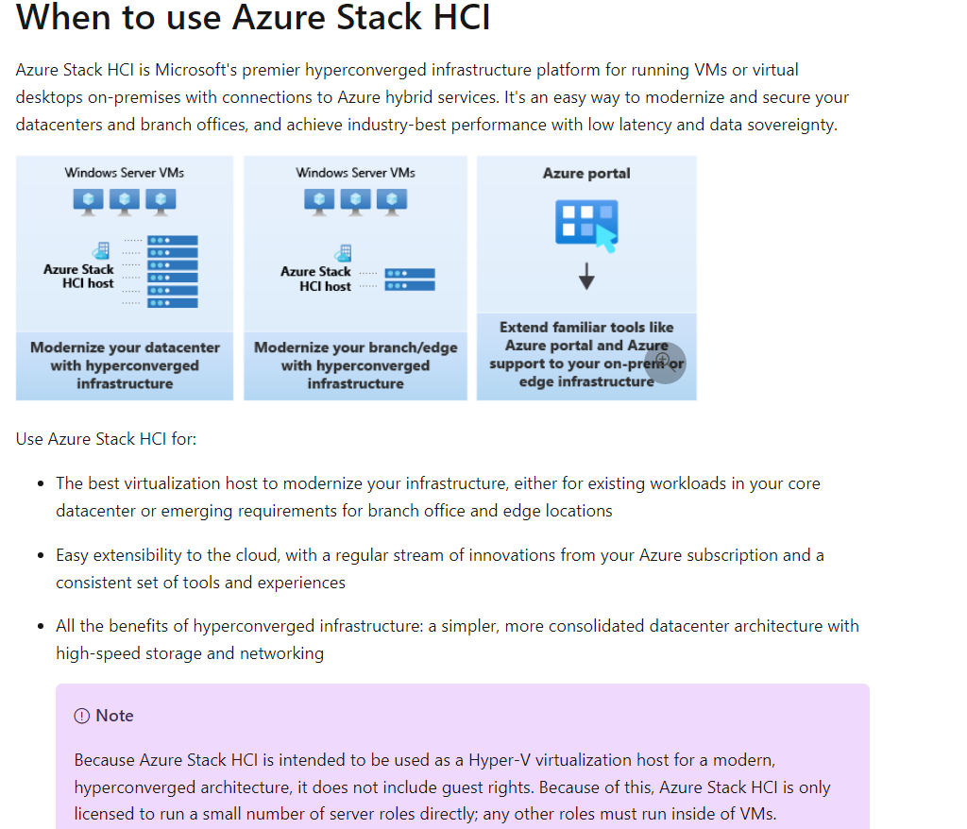

Choosing Identity Services:

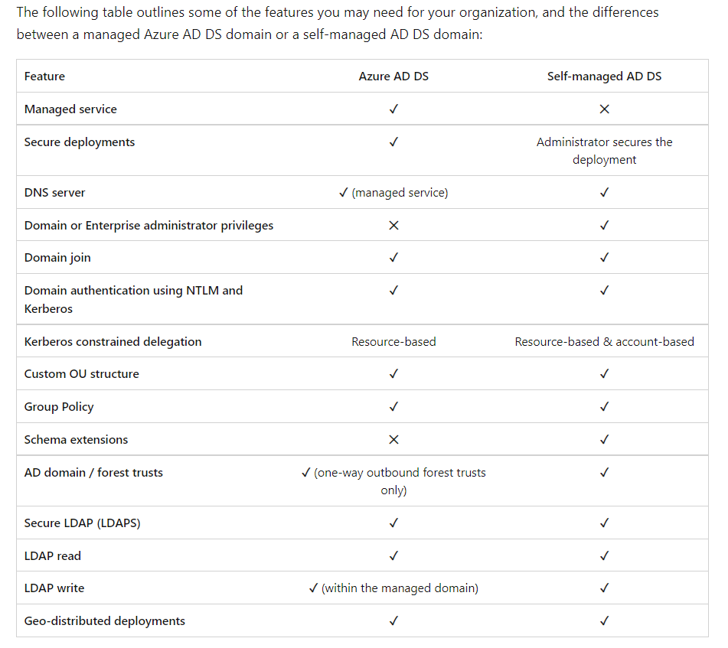

Hybrid Identity authentication:

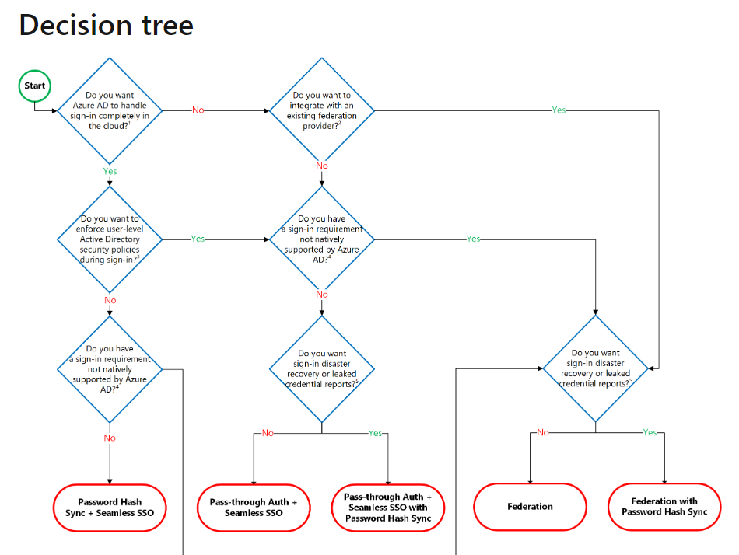

Managed disks types:

<https://docs.microsoft.com/en-us/azure/virtual-machines/disks-types?view=azs-2108&toc=https%3A%2F%2Fdocs.microsoft.com%2Fen-us%2Fazure%2Farchitecture%2Ftoc.json%3Fview%3Dazs-2108&bc=https%3A%2F%2Fdocs.microsoft.com%2Fen-us%2Fazure%2Farchitecture%2Fbread%2Ftoc.json%3Fview%3Dazs-2108>

Datastore Select candidate:

<https://docs.microsoft.com/en-us/azure/architecture/guide/technology-choices/data-store-decision-tree?view=azs-2108>

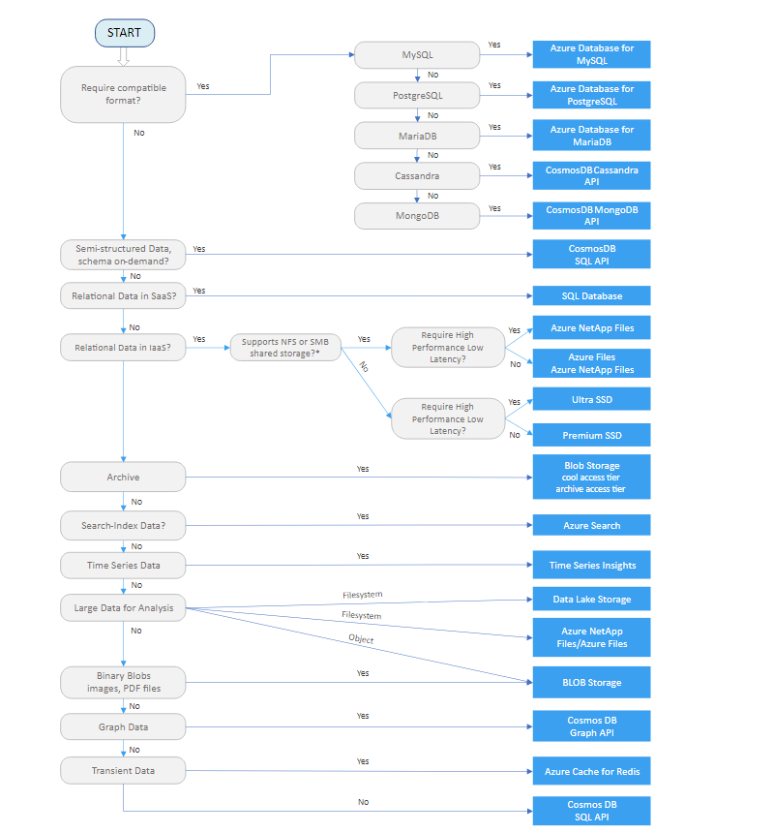

Choose network services:

URL: https://docs.microsoft.com/en-us/azure/architecture/guide/technology-choices/load-balancing-overview?view=azs-2108Load Balancing Options:

